ICP 13

Speech to Text and Text to Speech

ICP Group 4

Name: Sailaja Narra

Email: [sntnn@umsystem.edu](mailto:sntnn@umsystem.edu)

ICP Report:

<https://drive.google.com/file/d/1BUFyIlBahit5KijDovyjVWYVObfcCM4V/view?usp=sharing>

ICP Video:

<https://umsystem.hosted.panopto.com/Panopto/Pages/Viewer.aspx?id=3e7f87b4-ca6b-4b19-a5d1-adf40151a2db>

GitHub (Sourcecode):

<https://github.com/UMKC-APL-WebMobileProgramming/ICP13-sailajanarra/tree/main/Source>

My Partner

• Partner: Venkata Mahesh Mokkapati

• Email: [vmzwn@umsystem.edu](mailto:vmzwn@umsystem.edu)

• Repo: <https://github.com/UMKC-APL-WebMobileProgramming/ICP13-Mahesh68>

**Task:**

Creating a medical assistant for suggesting the user some medicines and make this app user friendly.

Initially some source code has been given and asked to make some step by step approach to convert speech to text and text to speech from the application.

**1.Use the layout given in the second use case speech to text.**

So for this layout is designed as following

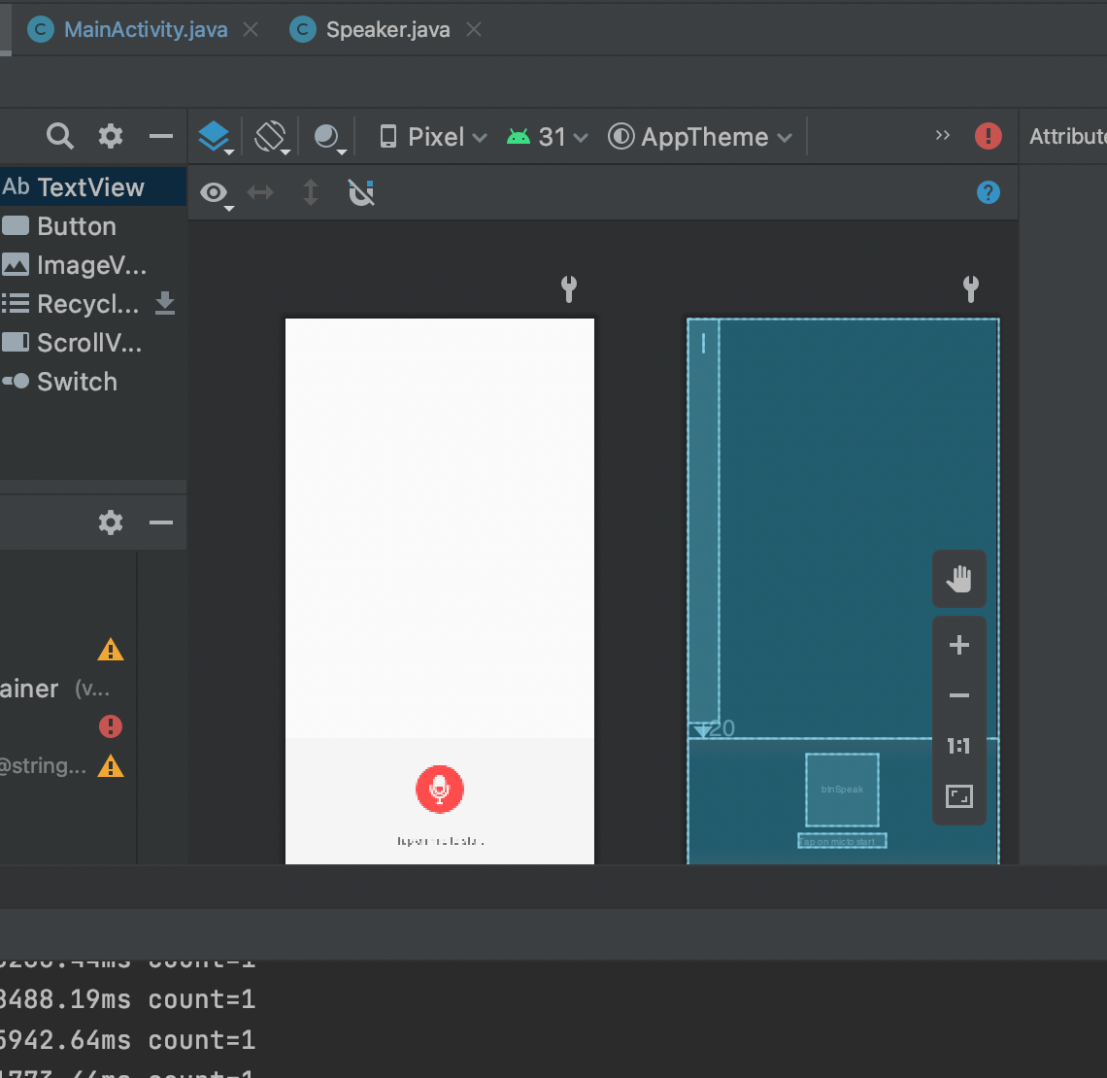

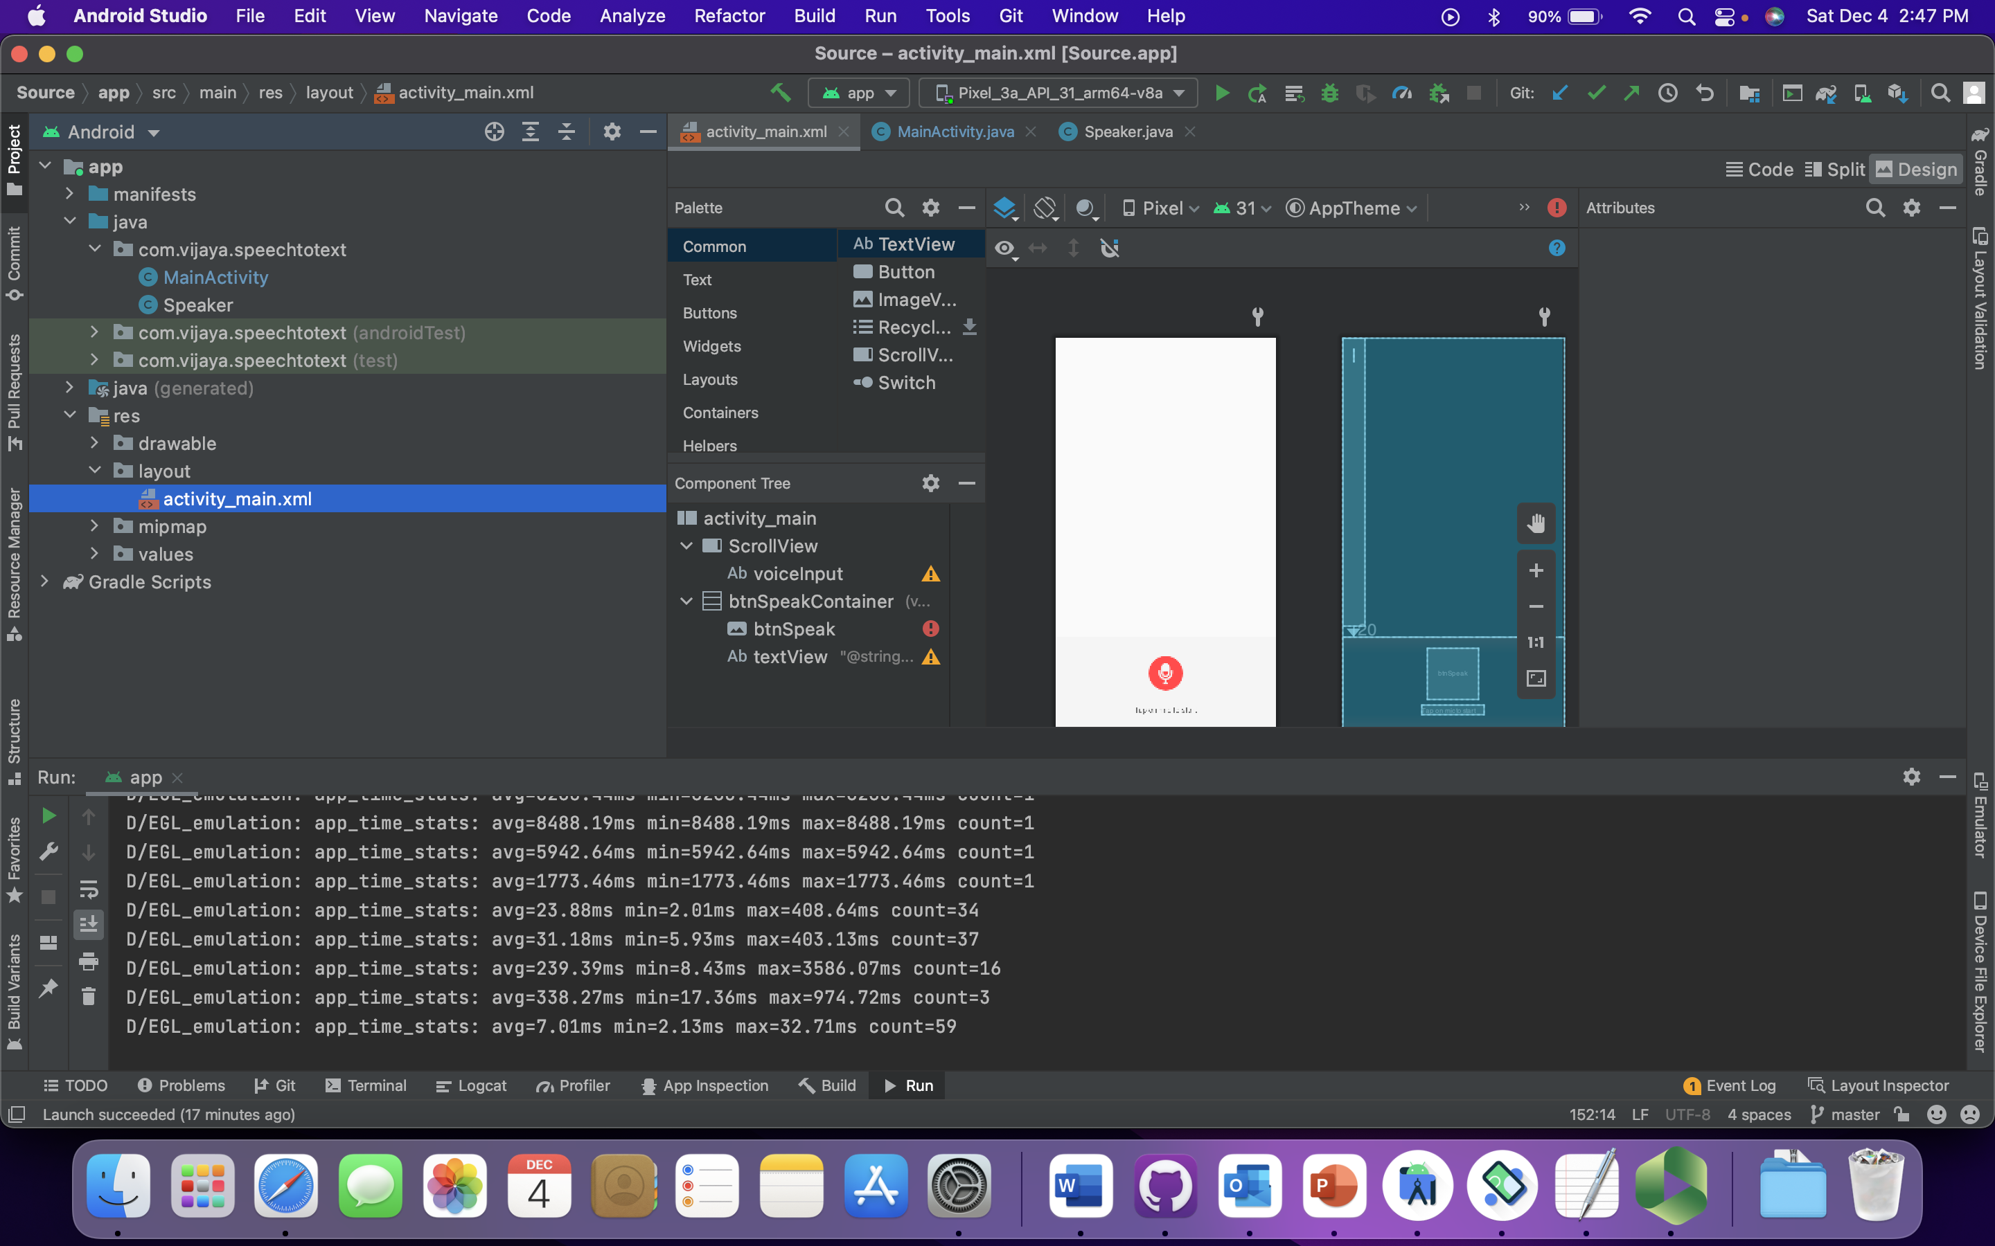

This is given in the source code and made some small improvements.

**2.As soon as the app opens,it should say hello**

For this we make use of Text to speech API and set the parameters to the desired text ouput.

So that it will speak the text which is given as input to this API.

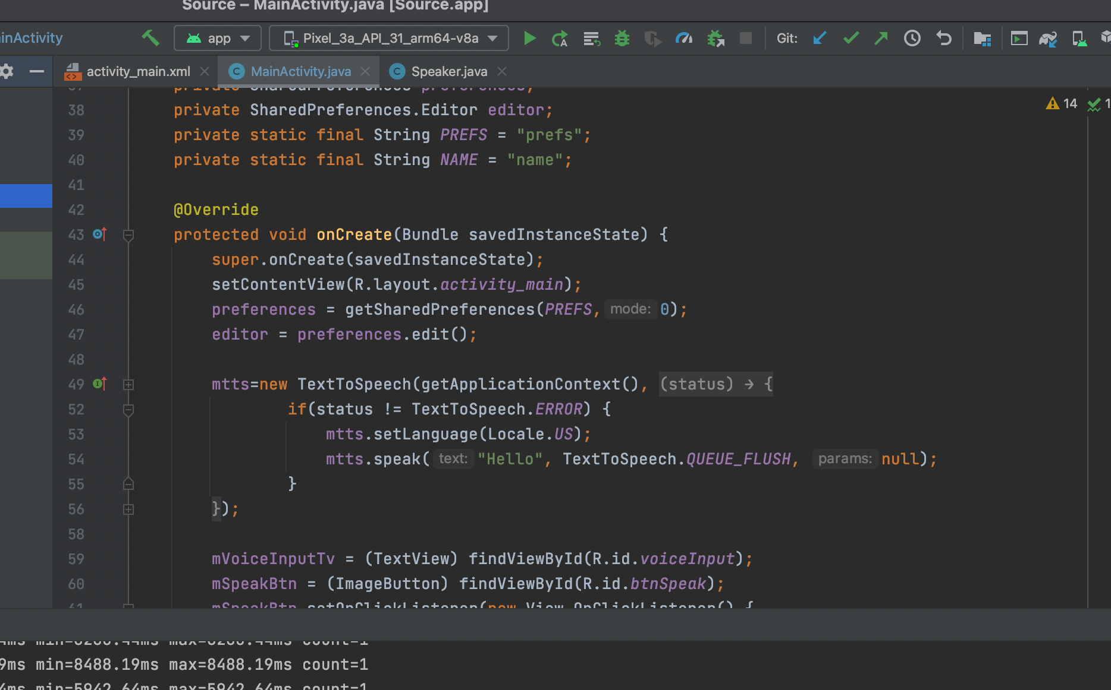

**3.Then the user clicks on the mic button to say hello**

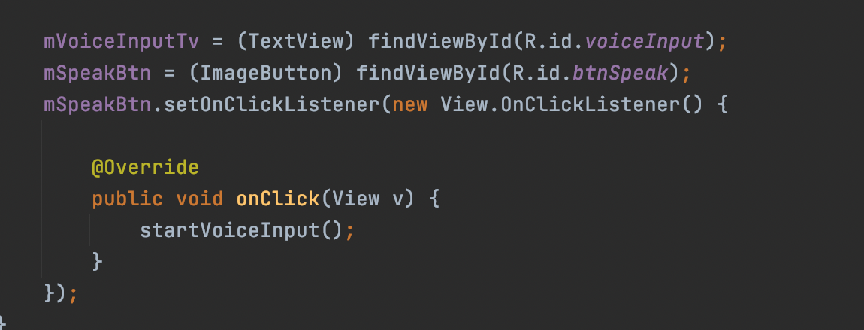

So when the user clicks on the mic button this on click listener is called and voiceinput method will be called.

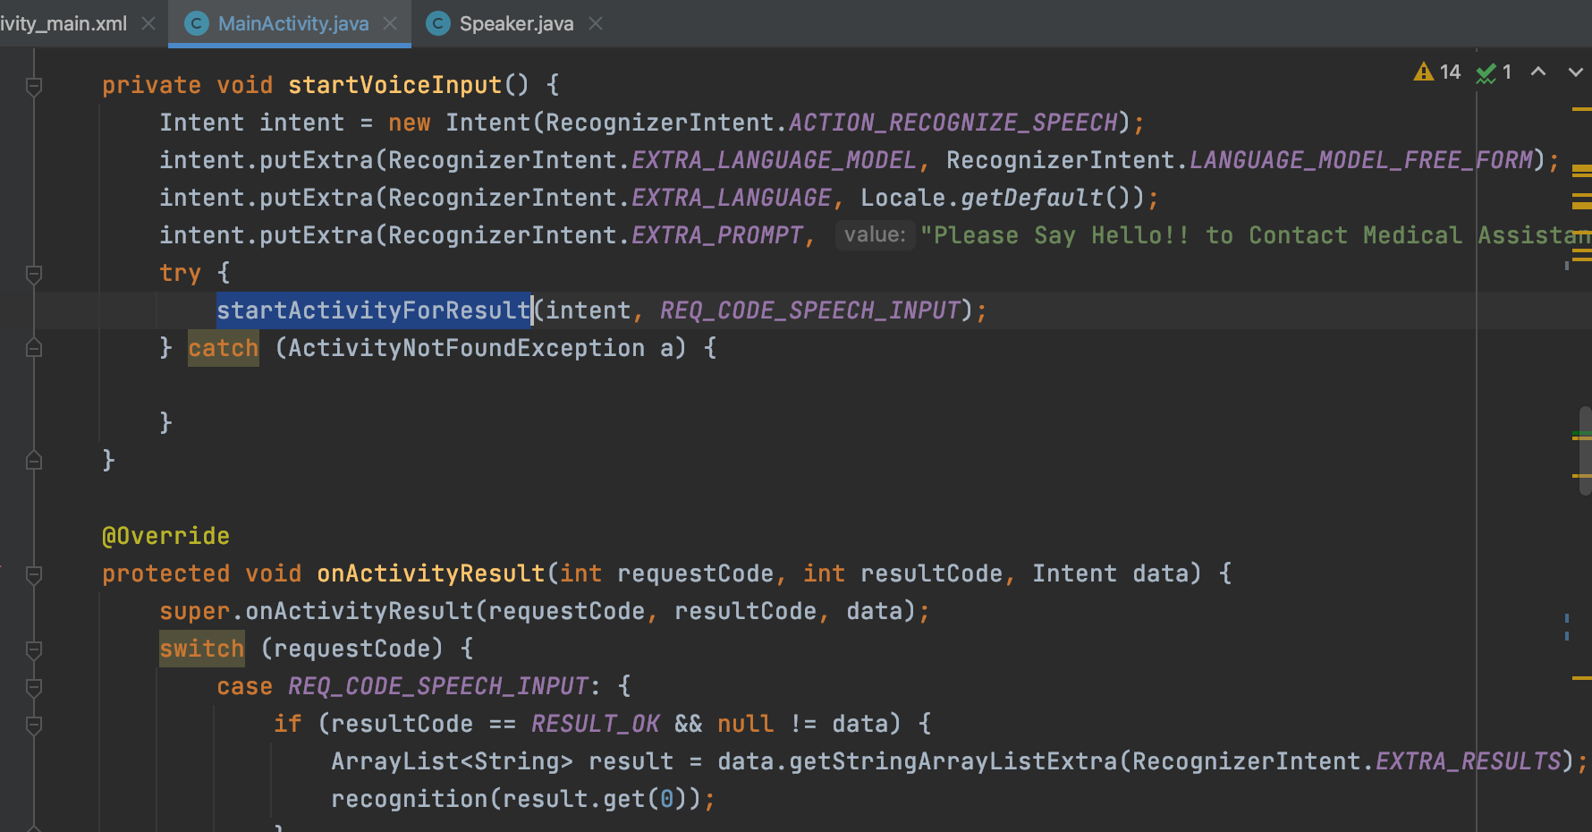

So when the user clicks on mic button some text will be shown to the user so that user interaction will happen.

So here we are displaying “Please say hello to medical assistant”

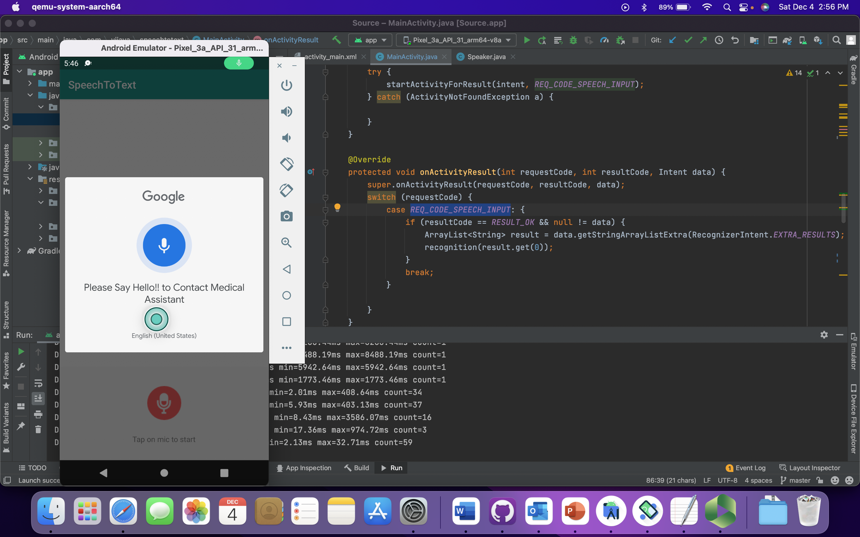

So form here manual interaction with the application takes place and it is as following:

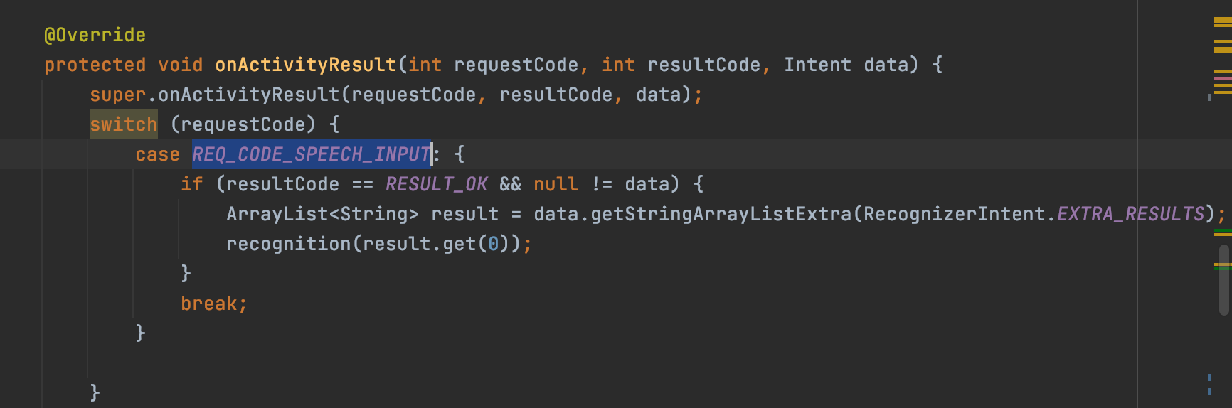

User interaction has these following words then respective speech will be given from the robo:

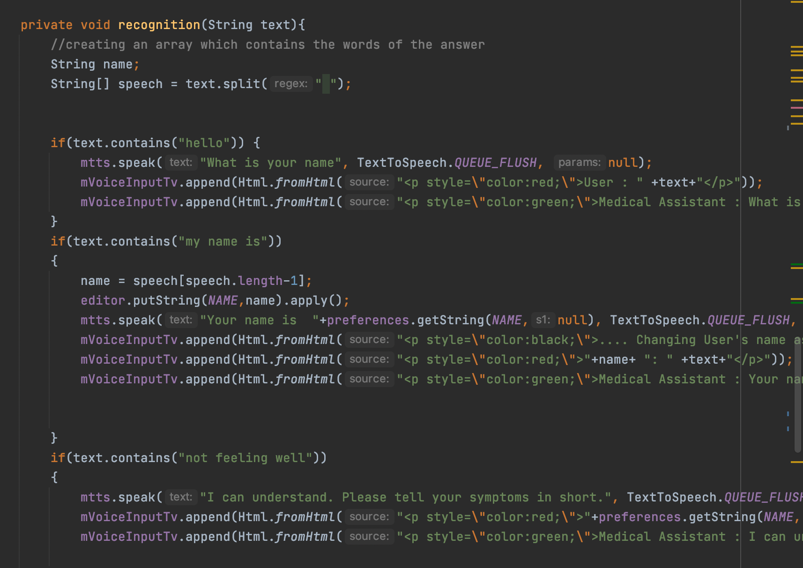

**4.Once the user said hello,the app should speak,"what is your name?"**

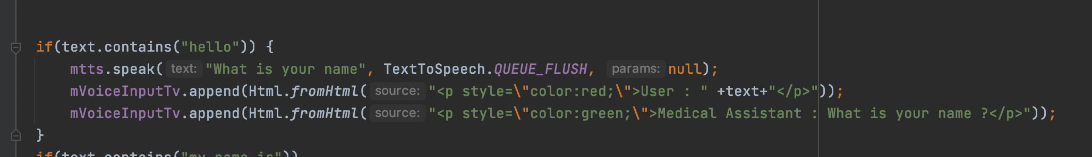

With this code the audio that is extracted from the audio is stored in an array and that is passed to the recognition method.

Here if that text contains any of the hint words then we are letting the API to speak the given text to the user.

**5.Then the user clicks on the mic button to say, "My name is"+<your name>**

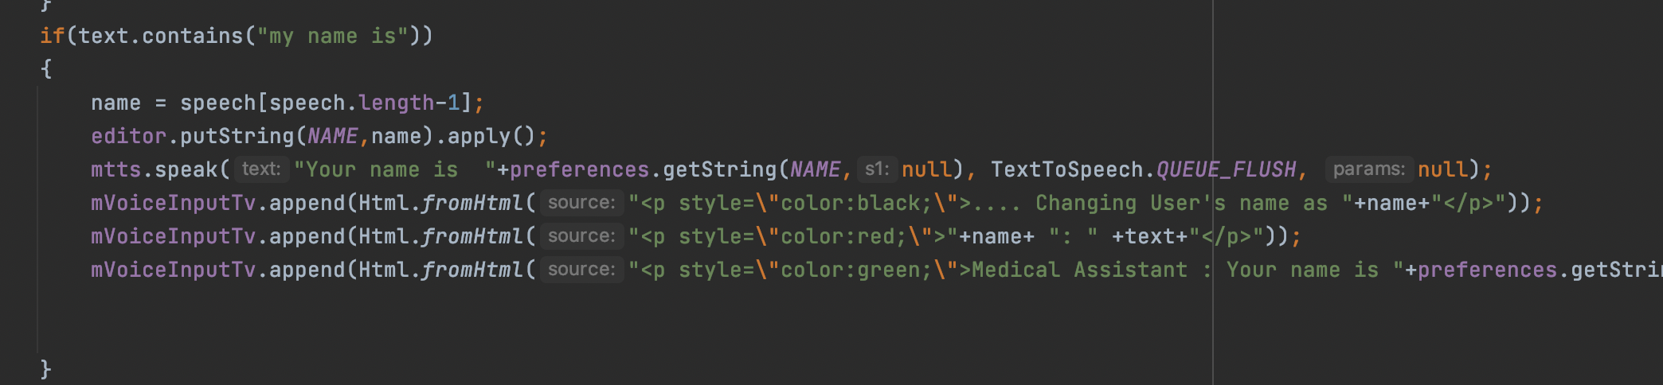

**6.Extract the name of the user and then save it as editor level.**

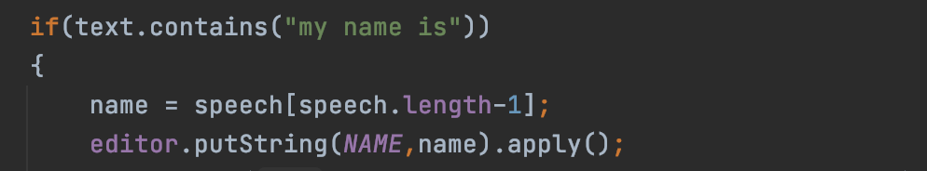

**7.Also,show the name on the screen**

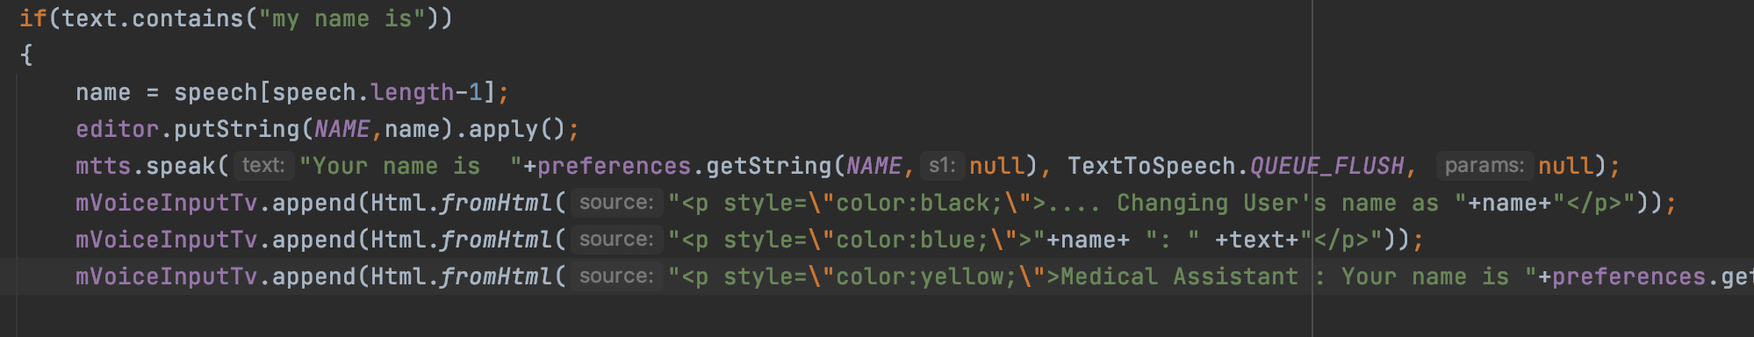

**8.When the user asks the following questions, appropriate answers should be given:**

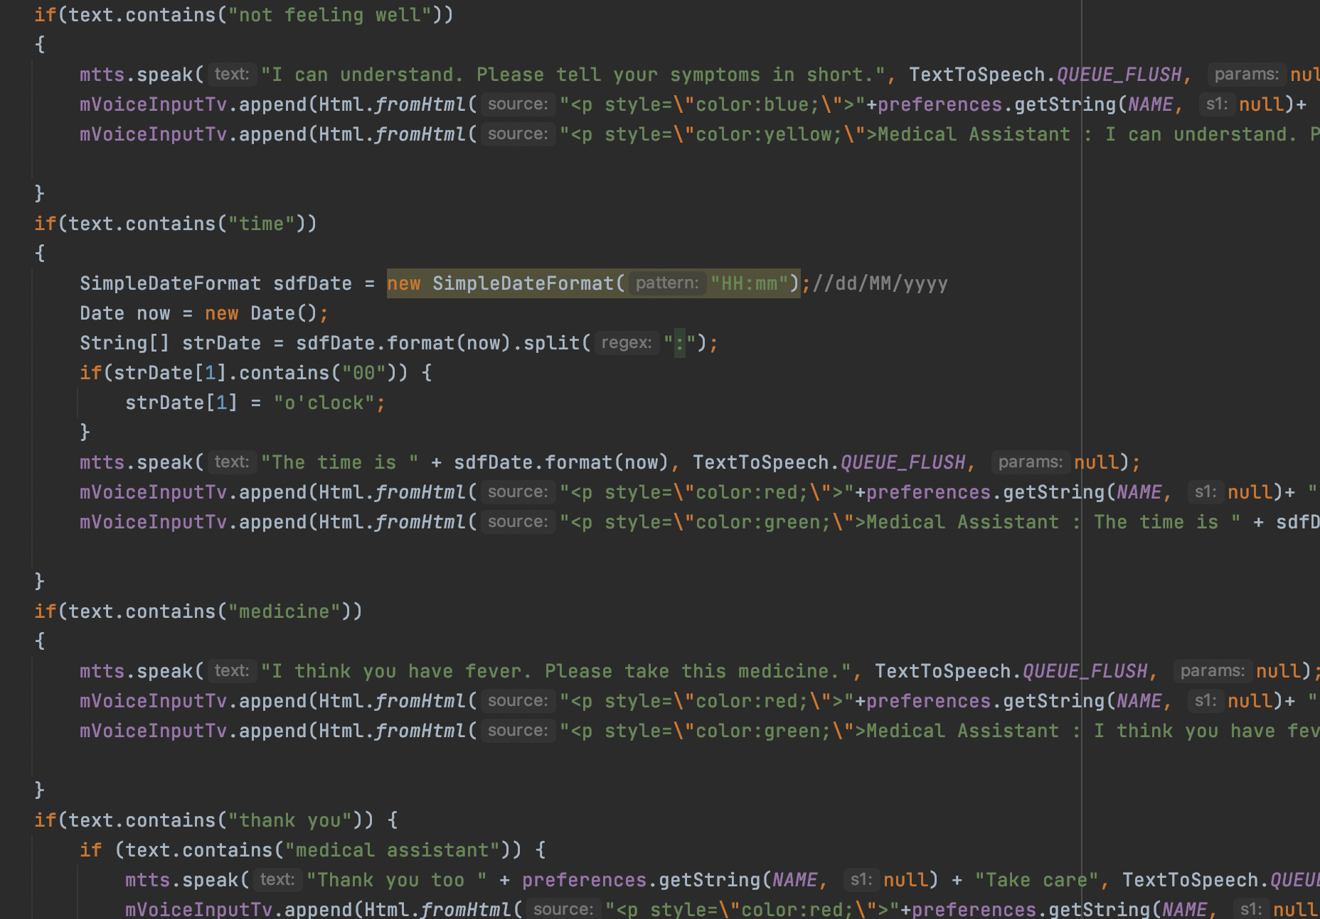

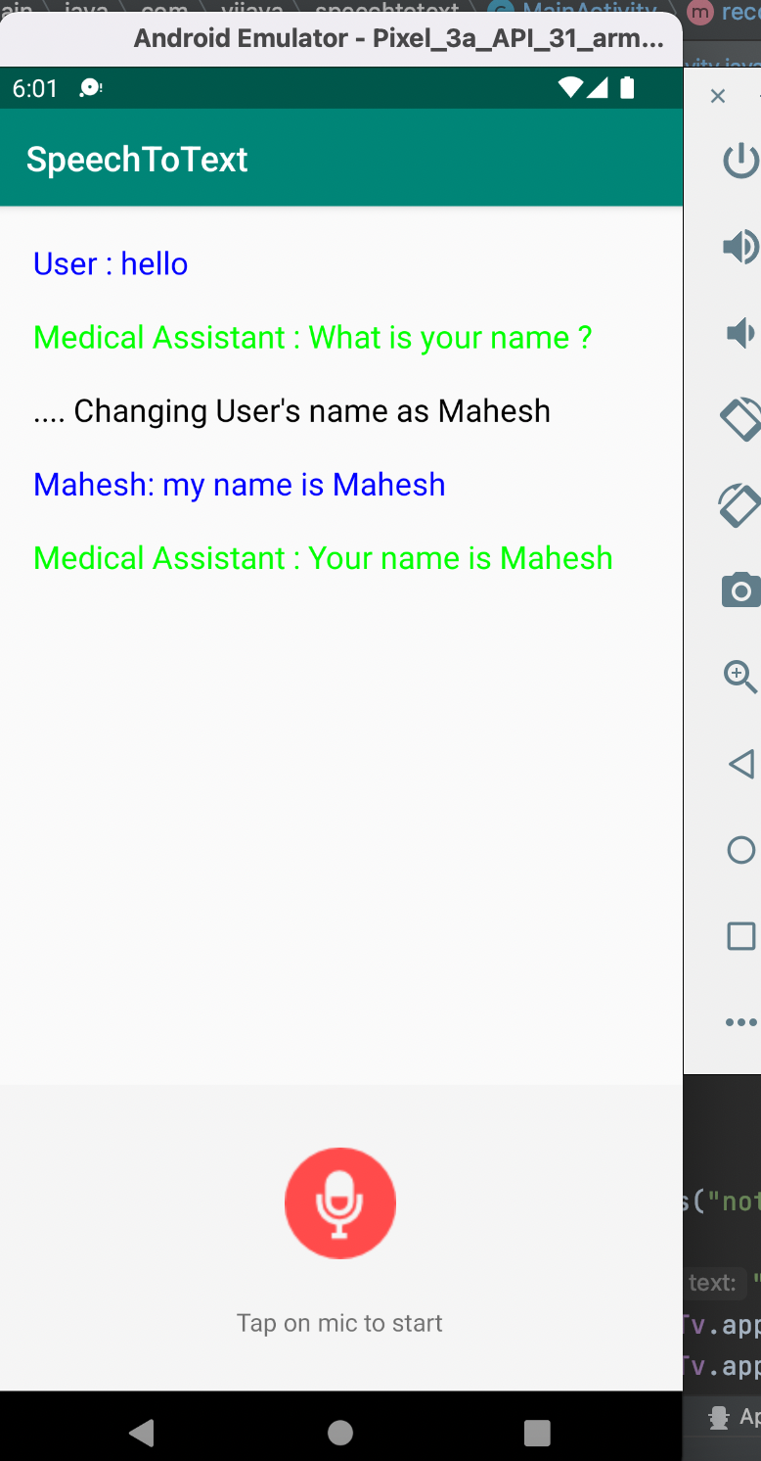

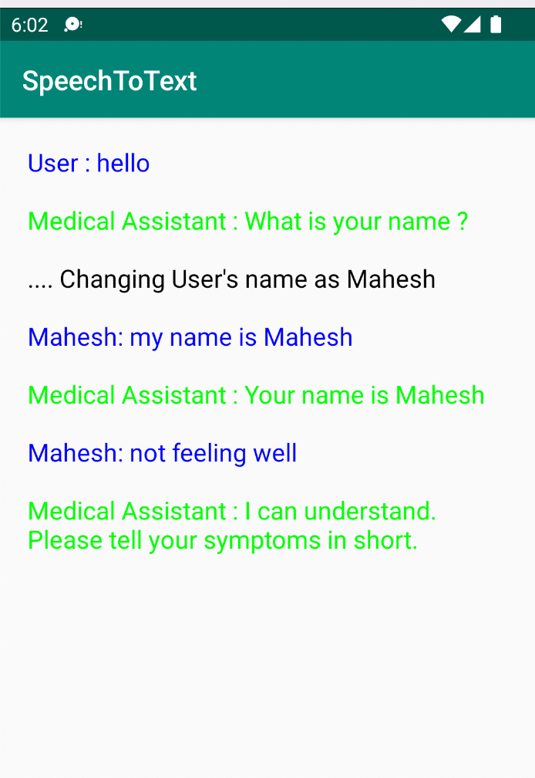

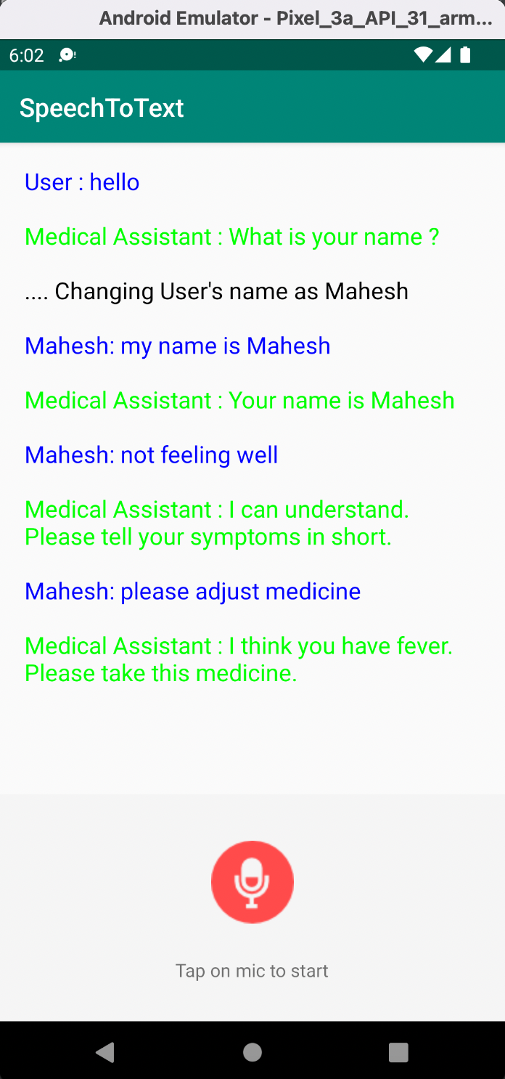

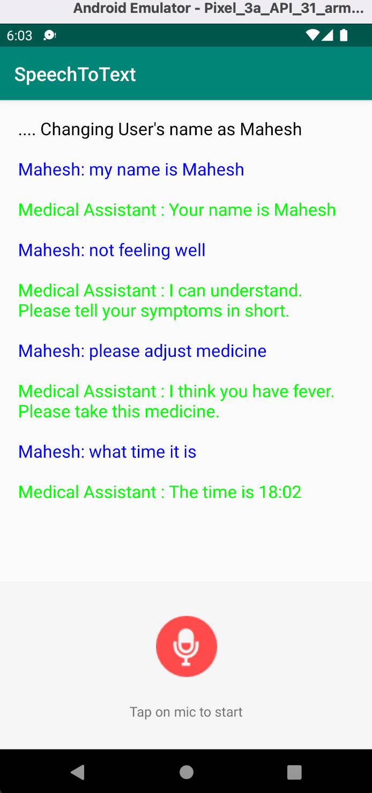

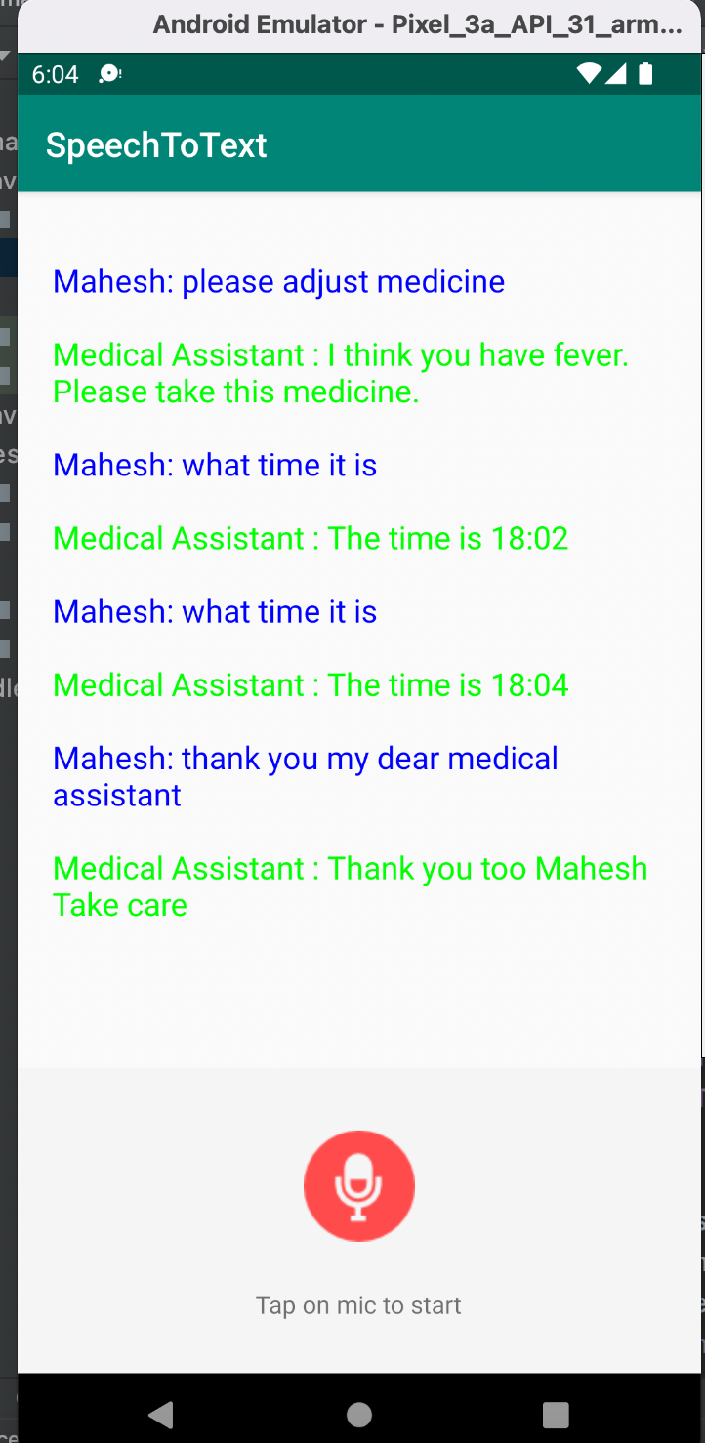

With this tasks are successfully completed for this ICP.

**Summary**:

We learnt about some of the google voice to text and voice to text APIs and made use of these API in the tasks.

Thank you.